**Artificial Intelligence Project**

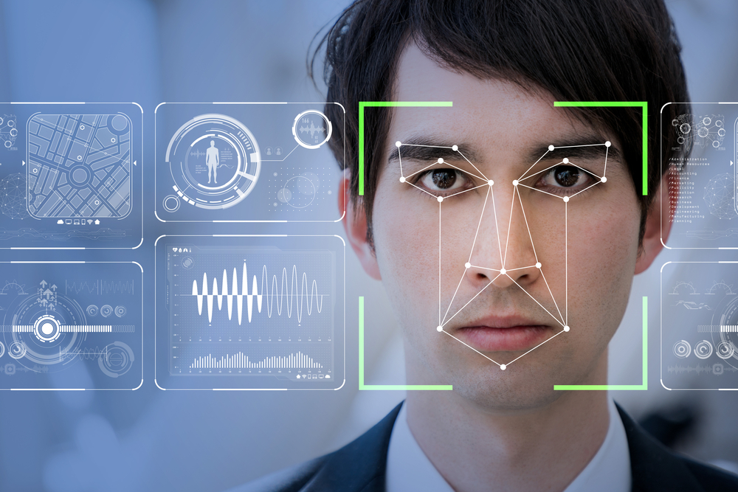

Project Report

ARTIFICIAL INTELLIDENCE

Course Instructor : Professor Mr. Siraj Munir

# Group Details

**Team Name:**



# Details of Team Members:

* Muhammad Ammad –

The team consist of only one members took the initiative to implement the concept of the Local Binary Search Histogram (LBPH) Algorithm

# Project Details

**Introduction:**

My project is a “Face Detection and Recognition System”. In this project, we will do the face detection and face recognition. It is a course project of the “Artificial Intelligence”. Basically, we are using the pre-define library of “Opencv” and “The Local Binary Pattern Histogram (LBPH) Algorithm”. We will detect the face of the user and then stored the images as dataset and after that we will train or model on the given data and finally we will perform the detection in which it will compare the runtime image and the images we have given to the system as dataset. At the end it will give the result in a couple of seconds.

**Methodology:**

In this project, we will convert and will do all the work on “Gray images” because the by default the images is in “Red Green Blue (RGB) sequence” the processing of the RGB image is very difficult and complex. First of all we will detect the images of the user and maintain a dataset for face detection we will use a pre-define function “haarcascade_frontal_face_default.xml” of “Opencv”. After that we will train or model by loading all the images of dataset in the lists and array. At the end, we will do recognition, for this we have “The Local Binary Pattern Histogram (LBPH) Algorithm”. The algorithm will convert the image in the binary code pattern and on the basis of it the images will be compare. This algorithm works like it focus on one single pixel and around that one pixel it also involve the eight more pixel, image is given below which will give allow you to understand better. After comparison the result will be generated in case of successful comparison the name of the user will be written on the camera screen below the face of the user otherwise “Unknown or Face Not Found” will written on the camera screen below the face of the user.

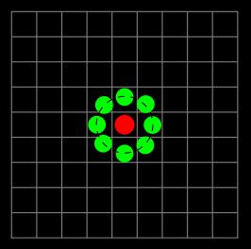

**Software:**

* Language:
  + Python
* Platform:
  + PyCharm
* Libraries:
  + Opencv-
  + Numpy
* Algorithm:
  + The Local Binary Pattern Histogram (LBPH) Algorithm

**GitHub Link:**

https://github.com/muhammadammad5555/Face-Detection-and-Recognition-System

**Conclusion:**

This project is an implementation of the Artificial Intelligence. The Artificial Intelligence refers to make a computer/machine/system intelligent artificially means by given it the knowledge and upon that knowledge it gives the result or answer. So her by giving a knowledge/dataset of images to the system we make a system capable to recognize a face.

**Thank You Very Much**